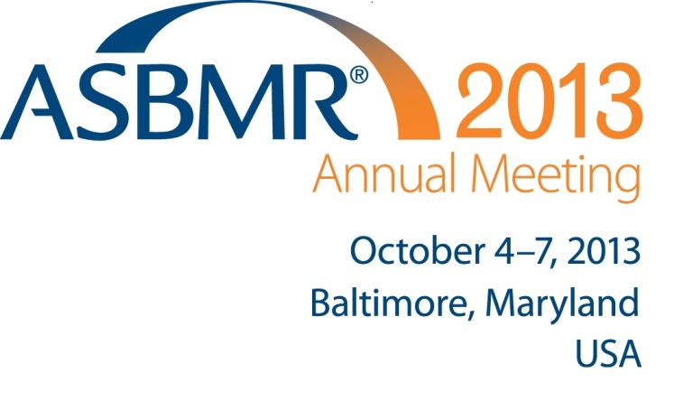
OCTOBER 4-7, 2013
EMBARGOED (Please note the release time for each study)

CONTACT:

Amanda Wood

(202) 367-2302
awood@asbmr.org

Dionne Dougall-Bass
(301) 961-5803 dionne@burnesscommunications.com

Latest Research on Osteoporosis, Bone Fractures in Men, Calcium and Vitamin D Supplements and New Treatments for Bone Disease Released at
American Society for Bone and Mineral Research 2013 Annual Meeting in Baltimore

Editor’s Note: For access to session abstracts and the online press room, please contact Amanda Wood at awood@asbmr.org.

Baltimore, MD – New research on calcium supplements and vitamin D, risk of fractures in older men, and the new culprit in bone fractures, weak muscles, and more will be released at the American Society for Bone and Mineral Research (ASBMR) 2013 Annual Meeting in Baltimore, the largest scientific meeting in the world on bone and mineral metabolism. Thousands of the world's leading bone health scientists and clinicians will attend. Key findings include:

Calcium Supplements a Heart-Healthy Option for Older Men
EMBARGOED UNTIL OCTOBER 4, 2013, 11:00 AM (EDT)

A new study shows that neither calcium supplements nor increased dietary calcium increases the risk of dying from a heart attack or other heart-related conditions in older men. Researchers from the University of California, San Francisco, studied a group of 5,967 men over the age of 65 and followed their calcium supplements and dietary calcium intake for a decade.

Previous studies raised concerns that calcium supplements or high dietary calcium could increase death as a result of heart-related problems, such as heart attacks and sudden death; yet, calcium is a critical component in bone health, even in the elderly. Low intake of calcium in older men can significantly increase the risk of fractures, which can lead to a downward spiral in both physical and mental health, and even be fatal. The risk of death is especially high for those who experience a hip fracture – one in five seniors who suffer a hip fracture die from complications within a year.

“These results are reassuring because heart disease is common in men, and any increase in risk from calcium would have an important impact on public health,” said Douglas Bauer, MD of the University of California, San Francisco, and lead author on the study. “And equally important, it indicates that calcium supplements or calcium from the diet may be a safe and easy way to maintain bone health in this group.” More information is available here.

New Study Confirms Calcium and Vitamin D Supplements a Safe Option for Older Women
EMBARGOED UNTIL OCTOBER 4, 2013, 11:15 AM (EDT)

Much of the research in the past years about the safety of using calcium and vitamin D supplements has left women and their physicians confused by different conclusions. While beneficial for bone health, the use of calcium and vitamin D supplements have also been connected to an increased risk of myocardial infarction in elderly women.

A new systematic review of the available research confirms calcium supplements, with or without vitamin D supplements, do not increase the risk of heart disease or death in older women.

These supplements are widely used by older women to maintain their bone health and prevent fractures as they age. “We have looked at the outcomes of different trials and shown that calcium and vitamin D supplements are not linked to heart disease risk,” said author Dr. Joshua Lewis from the University of Western Australia whose research is supported by the Raine Foundation. “Where elderly women cannot meet the recommended daily intake for calcium or vitamin D through diet alone, calcium tablet supplementation with vitamin D should be endorsed.” More information is available here.

Weak Muscles New Culprit in Bone Fractures in Older Men
EMBARGOED UNTIL OCTOBER 4, 2013, 11:30 AM (EDT)

Degenerative loss of muscle mass, quality and strength combined with weak bones doubles the risk of fractures in older men, researchers found. The study tracked approximately 5,700 older men and 1,000 women for up to nine years, but the additional risk was seen in men. Men with both osteoporosis or osteopenia combined with weak muscle—a condition called sarcopenia—had the highest risk.

"It is important for us to understand how risky the combination of weak bones and muscles is for older men,” said Didier Chalhoub, MD, MPH, of the University of Pittsburgh, lead author on the study. “Taking a wholistic approach by measuring both muscle and bone mass and strength may help identify men who are at risk of fracture before the breaks occur, and ultimately we should be able to decrease the fracture risk of the growing number of elderly men.”

Bone and muscle interaction has become a priority research topic for bone scientists as more and more research shows the connection may be critical for preventing fractures in the elderly. Indeed, muscle, and specifically the weakening of the skeletal muscle which is connected to bone, appears to play a significant role in fractures. More information is available here.

Note: ASBMR will dedicate a day-long symposium to this at the Annual Meeting in Baltimore on Thursday, October 3.More information is available here.

New Treatment for Hereditary Rickets
EMBARGOED UNTIL OCTOBER 6, 2013, 9:15 AM (EDT)

Bone researchers have developed a potentially safer and more effective treatment for an inherited form of rickets—known as X-linked hypophosphatemia (XLH)—a deforming disease of the skeleton associated with low blood levels of phosphate. Earlier work identified the gene mutation that causes the disorder, and it was later discovered that a growth factor mediates the disease, providing a target for a novel treatment approach.

In a phase 1 clinical trial, the researchers discovered that a single injection of the new treatment increases blood phosphate levels into the normal range for approximately one month.

“This medication holds promise as an improved treatment for XLH,” says Thomas Carpenter, MD, of Yale University, who led the study. Such an approach would eliminate the multiple daily dosing of the currently used regimen, which is awkward, unpalatable, and has inherent complications. "We believe that this breakthrough will essentially alter the way we treat XLH and we look forward to bringing this closer to a standard of therapy for the disease. We are hopeful that we will see a major increase in quality of life for those suffering with hereditary rickets.”

XLH is the most common form of inherited rickets, affecting approximately 1 in 10,000-20,000 children and adults in the U.S. More information is available here.

QUICK FACTS ABOUT BONE HEALTH

- Bone mass peaks around age 30 and then typically starts to decline.

- According to the Institute of Medicine, adults 19 years of age and older require about 600-800 International Units of vitamin D daily and 1000-1200 mg. of calcium daily through food and with supplements, if needed, with somewhat different amounts of these nutrients recommended for growing children (ranges depending on age and gender).

- Experts recommend bone density testing for women who have experienced any bone fracture at age 45 or older and at age 50 for women with a family history of hip fractures or other bone-related disease.

- All women over age 65 should receive a baseline bone density screening test, however these are under-utilized; Medicare covers bone density testing as a preventive benefit, yet only 13 percent of Medicare-eligible women receive this screening test.

- Osteoporosis is a devastating and costly disease affecting 10 million Americans; another 34 million have low bone mass, making them more susceptible to osteoporosis.

- Without intervention, one in two women and one in four men age 50 and above will experience a fracture due to osteoporosis. Many individuals – men and women – don’t even know they are at risk for the disease.

- In 2005, osteoporosis was responsible for an estimated two million fractures and $19 billion in costs.

- By 2025, experts predict that osteoporosis will be responsible for approximately three million fractures and $25.3 billion in costs each year.

For more information, please go to http://www.asbmr.org and see “Media” under the ASBMR 2013 Annual Meeting or contact Amanda Wood at awood@asbmr.org. ASBMR will update its online press room throughout the conference with new releases, conference highlights and images. For access, contact Amanda Wood.

###
The American Society for Bone and Mineral Research (ASBMR) is the leading professional, scientific and medical society established to bring together clinical and experimental scientists involved in the study of bone and mineral metabolism. ASBMR encourages and promotes the study of this expanding field through annual scientific meetings, an official journal (Journal of Bone and Mineral Research), the Primer on the Metabolic Bone Diseases and Disorders of Mineral Metabolism, advocacy and interaction with government agencies and related societies. To learn more about upcoming meetings and publications, please visit www.asbmr.org.

