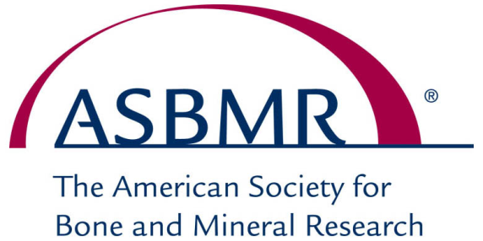
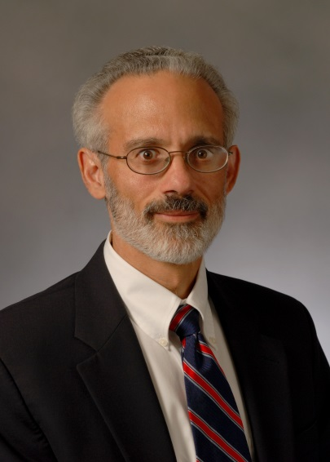

ASBMR President
Michael Econs, M.D.

Dr. Econs is the Glenn W. Irwin, Jr. Professor of Endocrinology and Metabolism and the Division Director of Adult Endocrinology and Metabolism at IU School of Medicine in Indianapolis.
His clinical interests are in the field of metabolic bone diseases including osteomalacias, osteoporosis, Paget’s disease, hyperparathyroidism and hypoparathyroidism. He is particularly interested in taking care of patients who have inherited metabolic bone disorders. His general area of interest is the genetic aspects of metabolic bone diseases. He played important roles in the discovery of the genes responsible for X-linked hypophosphatemic rickets (PHEX), autosomal dominant hypophosphatemic rickets (FGF23), autosomal dominant osteopetrosis (CLCN7), and osteoglophonic dysplasia (FGFR1). He continues to use the tools of clinical research, population genetics, bioinformatics, animal studies, molecular biology, and cell biology to study metabolic bone diseases.
Dr. Econs has served as an ASBMR Councilor, as President of the Council for the past year and has been the Chair of Ethics Advisory Committee and served as an ASBMR Councilor.

