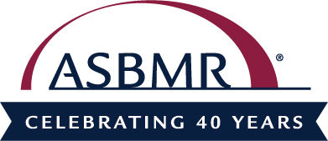

ASBMR President
Jane Cauley, DrPh

Dr. Cauley is a distinguished professor of epidemiology and Associate Dean for Research at the University of Pittsburgh Graduate School of Public Health and Co-Director of the Center for Aging and Population Health. Her research focuses on the epidemiology of osteoporosis, with special respect to the ethnic and geographic variability in fracture, osteoporosis treatment and the consequences of osteoporosis in both men and women. She is responsible for developing a major research area in calcium and vitamin D supplementation and the association between circulating 25 hydroxyvitamin D and health outcomes including fractures, physical performance and mortality. Her research also focuses on the physical and psychological changes that occur in postmenopausal women. She examines the use of estrogen, risks of hip fractures, bone density and cholesterol levels of women who are going through menopause.
Dr. Cauley serves as Principal Investigator (PI) for several large cohort studies including the Study of Osteoporotic Fracture and the Osteoporotic Fracture Risk in Older Men. She was Co-PI for the Women's Health Initiative and Director of the Epidemiology of Aging Training Program, both sponsored by the National Institutes of Health.
Dr. Cauley’s awards include: 2015, Chancellor’s Distinguished Research Award, University of Pittsburgh; 2014 - 2015, The World's Most Influential Scientific Minds, (Clinical Medicine), Thomson Reuters; 2013, the Golden Femur Award for her debate at the European Calcified Tissue Society meeting and 2011, ASBMR Frederic C. Bartter Award for outstanding clinical investigation in disorders of bone and mineral metabolism. She has mentored 32 PhD students and was awarded the Provost Award for Excellence in Mentoring from the University of Pittsburgh, 2011. Dr. Cauley has authored more than 730 papers for scientific journals and 22 book chapters, and she co-edited Epidemiology of Aging. She’s a member of the Society of Epidemiological Research, the American Public Health Association, the American Society for Bone and Mineral Research, the Endocrine Society and the Gerontological Society of America.

