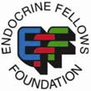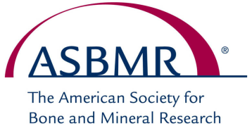

Sixth Fellows Forum on Metabolic Bone Diseases
October 10-11, 2012 – Minneapolis, Minnesota
APPLICATION FORM
----------------------------------------------------------------------------------------------------------------------------

NAME OF APPLICANT: _____________________________________________________________

NAME OF INSTITUTION: ___________________________________________________________

MAILING ADDRESS: _______________________________________________________________

__________________________________________________________________________________

CITY, STATE/PROV., POST CODE: ___________________________________________________

PHONE: _______________________________ CELL: _____________________________________

EMAIL: ___________________________________________________________________________

If M.D., Year of Fellowship as of July 1, 2012: □ 1st □ 2nd □ 3rd
Institution from which M.D. degree obtained:______________________________________________
Fellowship Specialty: ________________________________________________________________
(Endocrinology, Rheumatology, Geriatrics, Ob-Gyn, Ortho, etc.)
If Ph.D., year of Ph.D. degree: ________________________________________________
If in midst of Ph.D. Program, year of expected Ph.D. degree:_________________________
Focus of research or Ph.D. Thesis:
__________________________________________________________________________________

__________________________________________________________________________________

I am enclosing an abstract: Yes No I am attending the ASBMR 2012 Annual Meeting: Yes No

Program Director’s Name: ____________________________________________________________

I certify that the individual named above is actively enrolled in our training program and that the information provided above is accurate and valid.

Program Director Signature: ________________________________________ Date: _____________

Send this form and your abstract, if applicable, no later than Monday, July 9, 2012 to:
Endocrine Fellows Foundation
1310 19th Street, NW
Washington, DC 20036, USA
Phone: 877-877-6515; Fax: 202-223-1762
Email: info@endocrinefellows.org

