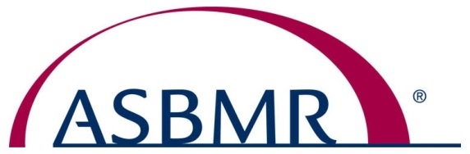
ASBMR President
Roland Baron, D.D.S., Ph.D.
Harvard Medical School and School of Dental Medicine, USA
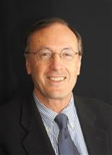

Dr. Roland Baron is the current president of the American Society for Bone and Mineral Research (ASBMR). He is Professor of Medicine, Harvard Medical School, Endocrine Unit - Massachusetts General Hospital and Professor and Chair, Department of Oral Medicine, Infection and Immunity, Harvard School of Dental Medicine (HSDM),
“My entire career has been devoted to the field of bone and mineral research,” stated Dr. Baron. “I see the future of ASBMR and of our field requiring strength in, and better communication between, all four pillars of medical science – connections between basic, clinical research and performed both in academia and in industry.”
Dr. Baron’s current research focuses on osteoclast and osteoblast biology; the transcriptional regulation of cell lineage determination; and the regulation of bone homeostasis.
Prior to his tenure at Harvard, Dr. Baron spent thirty years at Yale University School of Medicine (New Haven, CT) in the Departments of Medicine, Orthopedics and Cell Biology. A DDS and PhD graduate of the University of Paris (France), Baron has co-authored more than 300 scientific papers, and has trained more than 110 PhD, MD, DDS, MD-PhD and DDS-PhD students and postdoctoral fellows.
In addition, Dr. Baron is a past ASBMR Council member; a past recipient of ASBMR’s William F. Neuman Award, and Louis V. Avioli Founders Award; a recipient of the H. Copp Award from the International Bone and Mineral Society as well as the Excellence in Research Award from the European Calcified Tissue Society. He is the Founder and past Editor-in-Chief of Bone, a leading journal in the field. Dr. Baron also had a distinguished career in industry between 1994 and 2006 as Vice-President and Head of the Bone Diseases Therapeutic Area at Hoechst Marion Roussel and Aventis. He was also President and CSO of ProSkelia and later ProStrakan.

