Calling a Mentor/Mentee

- When the meeting is scheduled to begin, log in to your Program using your usual username and password.
- Go to the "relationships" Tab.
- Click on your Mentor/Mentee you wish to call
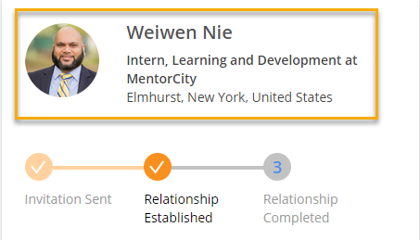
- Click on Join Meeting
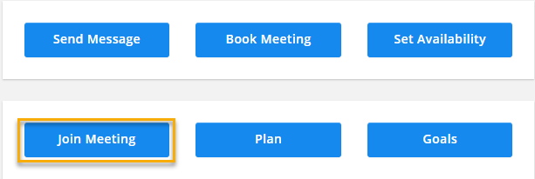
- You should see the Callbox come up on the lower Left-hand side of the screen, hit the Telephone button to start the call.
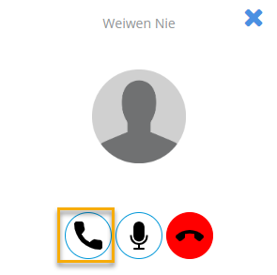
- You will then hear a normal ring tone until the other party accepts the call. If the call drops after a short ring or two, it may mean that your mentoring partner isn't logged into the platform yet.
- Once the conversation has wrapped up, click on the red phone icon to disconnect.

- As the caller, you will be able to navigate the website freely.
- Make sure you do not close the window the call is placed in; otherwise, it will drop the call prematurely.
- Two parties cannot call each other at the same time

Accepting a call from a Mentor/Mentee

- When the scheduled meeting is about to start, log into the MentorCity platform.
- Once a call comes through, you will receive a message stating the caller's name.
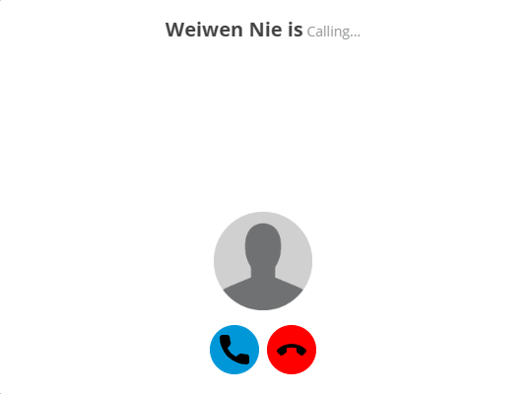
- Click on the Blue Phone Icon to accept the call.
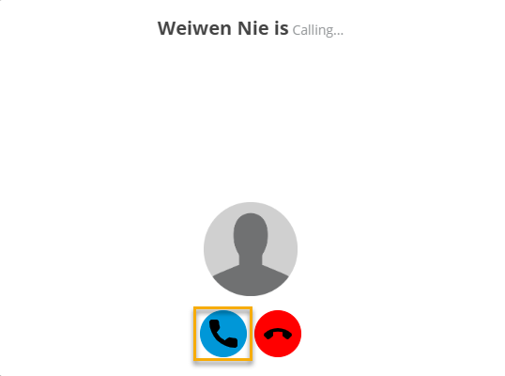
- Once the conversation has wrapped up, click on the red phone button to disconnect.
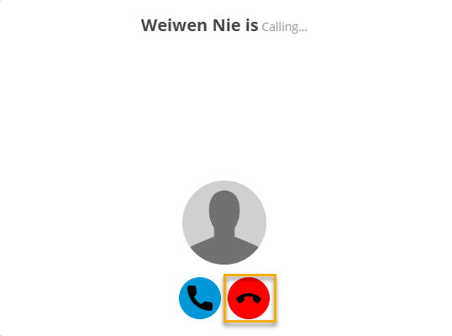

- As the receiver of a call, do not close the window/tab that the call is on. Doing so will disconnect the call prematurely.
- At the time you are expecting a call, make sure only to have one tab open.
- To navigate the platform freely, open another window/tab in your browser.
- Two parties cannot call each other at the same time

The Interface

- Start call – Accept the call, or place the call
- Mute – Mute your microphone.
- End Call
